**B2B Sales Guide: Mastering Prompts**

**Prompt Engineering for AI-Driven Solutions**

**Introduction**

In the era of Artificial Intelligence (AI), **prompt engineering** has become a cornerstone for

leveraging AI models effectively. For technical sales professionals, mastering prompt

engineering can unlock new levels of productivity, precision, and customer engagement.

This guide provides a structured approach to crafting high-quality prompts that align with

business objectives, ensuring AI-generated outputs are actionable, relevant, and impactful.

**Core Components of Prompt Engineering**

**1. Persona**

• Define the role the AI should assume. For example:

• *"You are a senior salesman at a multinational company with 10 years of*

*experience in the automotive industry."*

• **Why it matters:** Assigning a persona ensures the AI generates contextually appropriate

responses tailored to the target audience.

**2. Context**

• Provide background information to guide the AI. For example:

• *"You have just closed a contract 30% larger than expected with a major industry*

*customer."*

• **Why it matters:** Context helps the AI understand the scenario and generate outputs

that align with real-world business situations.

**3. Task**

• Clearly state what the AI needs to accomplish. For example:

• *"Write a 200-word email to your boss sharing the positive news of the contract*

*closure."*

• **Why it matters:** A well-defined task ensures the AI focuses on the desired outcome.

**4. Format**

• Specify the output format. For example:

• *"The email should include a project background section, a business result*

*section, and a thank-you note."*

• **Why it matters:** Formatting constraints ensure the output is structured and professional.

**5. Tone**

• Define the desired tone. For example:

• *"Use clear language and write in a confident yet friendly tone."*

• **Why it matters:** Tone ensures the output resonates with the intended audience,

whether it is a client, executive, or team member.

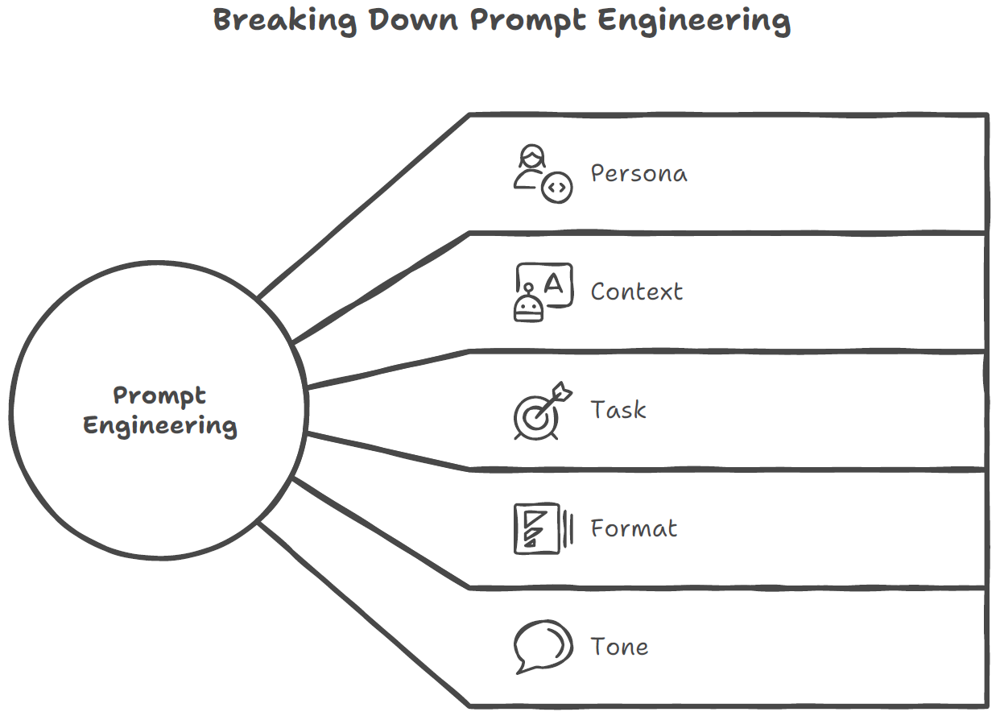

**Advanced Prompt Engineering Techniques**

**1. Use Clear and Concise Language**

• Avoid jargon and ambiguity. Use symbols like triple quotes **(""")** or triple hashes **(###)**

to separate sections within the prompt.

• **Example:** *"Write a 200-word email summarizing the key metrics of the newly closed*

*contract, including a 30% increase in revenue."*

**2. Be Specific**

• The more detailed the prompt, the better the AI's output. For example:

• *"Generate a sales pitch for our AI-driven project management tool, focusing on*

*ROI, ease of integration, and customer success stories."*

**3. Experiment and Iterate**

• Test different prompts and refine based on feedback. Use iterative feedback to

improve accuracy over multiple rounds.

• **Example:** *"Revise the email to make it more concise and highlight the financial impact*

*of the contract."*

**4. Multi-Step Prompts**

• Break complex tasks into smaller, dependent prompts. For example:

• Step 1: *"Create an outline for a marketing strategy."*

• Step 2: *"Expand each point in the outline with specific tactics."*

• Step 3: *"Summarize the strategy in bullet points for an executive briefing."*

**5. Ask for Multiple Versions**

• Request several versions of the output to choose the best one or combine elements

from different responses.

• **Example:** *"Provide three versions of the sales pitch, each with a different focus: ROI,*

*ease of use, and customer testimonials."*

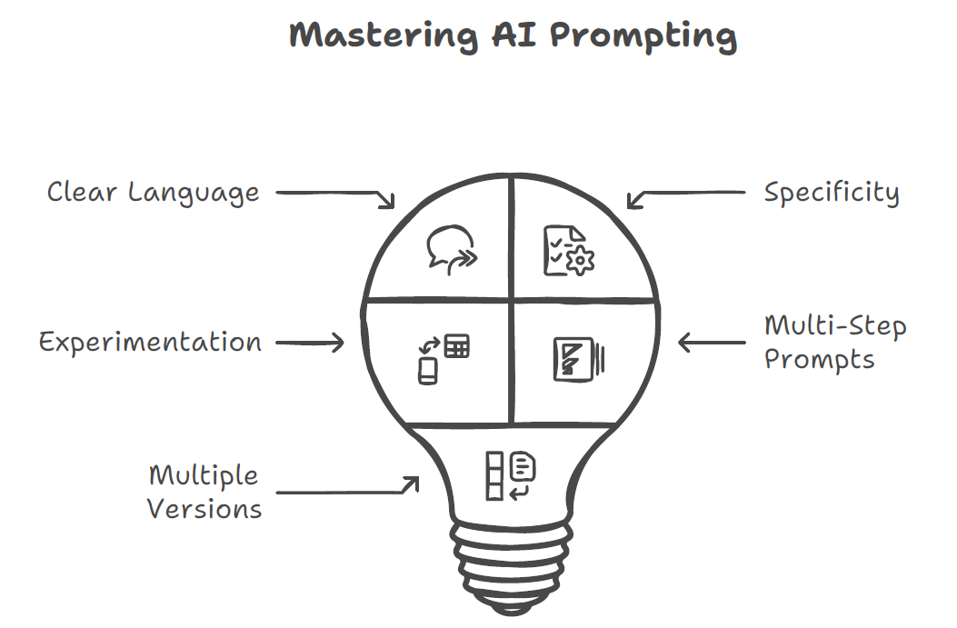

**Applications in Technical Sales**

**1. Email Communication**

**• Prompt Example:** *"Write a 200-word email to a client, highlighting the benefits of our*

*new product and including a call-to-action for a demo."*

**2. Content Creation**

• **Prompt Example:** *"Generate 5 engaging social media post ideas for promoting our*

*latest software release."*

**3. Market Analysis**

• **Prompt Example:** *"Summarize the top 3 trends in adhesive technologies for 2024,*

*including potential market impact."*

**4. Sales Pitches**

• **Prompt Example:** *"Create a persuasive sales pitch for our AI-driven project*

*management tool, focusing on ROI and ease of integration."*

**5. Customer Engagement**

• **Prompt Example:** *"Draft a personalized follow-up email for a client who attended our*

*webinar, including a link to the recording and a special offer."*

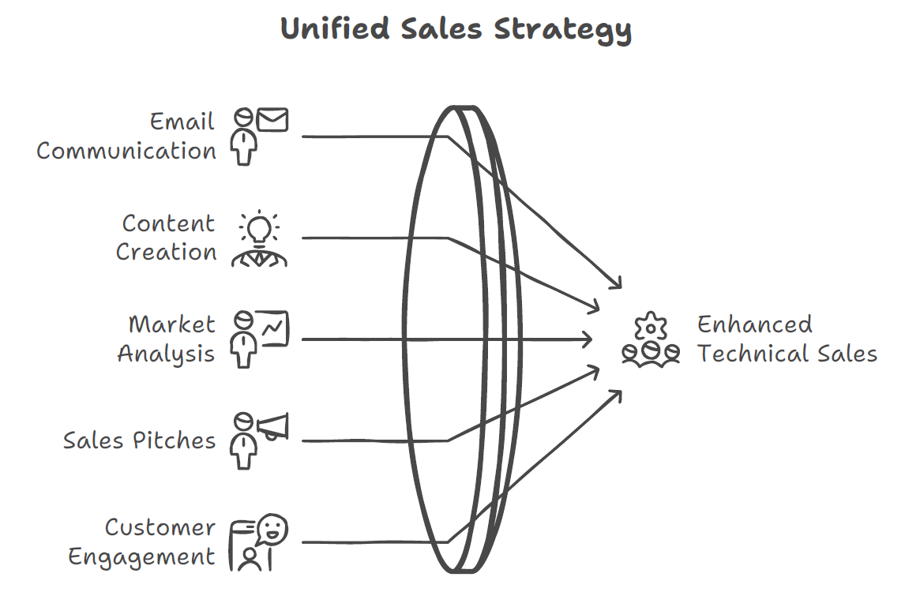

**Best Practices for Technical Sales Teams**

**1. Leverage AI for Competitive Analysis**

• Use prompts to analyse competitors' positioning, customer demographics, and

industry trends.

• **Example:** *"Compare our product features with those of our top three*

*competitors and highlight our unique selling points."*

**2. Enhance Customer Engagement**

• Generate personalized email templates, product descriptions, and follow-up

messages using AI.

• **Example:** *"Create a series of personalized emails for a lead nurturing campaign,*

*focusing on pain points and solutions."*

**3. Streamline Reporting**

• Automate the creation of sales reports, executive summaries, and performance

metrics with AI-generated content.

• **Example:** *"Summarize last quarter’s sales performance in bullet points,*

*highlighting key metrics and areas for improvement."*

**4. Improve Team Collaboration**

• Use AI to brainstorm innovative ideas, plan projects, and create engaging

presentations.

• **Example:** *"Suggest 5 team-building activities to enhance collaboration and*

*communication within the sales team."*

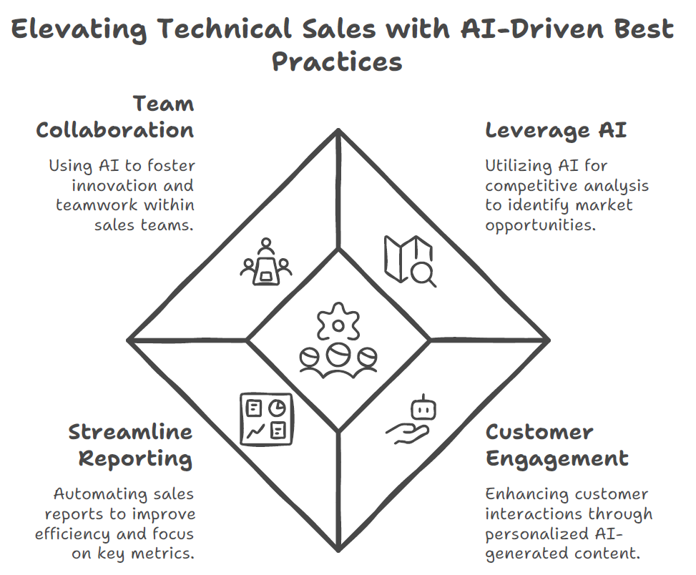

**Conclusion**

Prompt engineering is a significant change for technical sales teams, enabling them to harness

the full potential of AI for better decision-making, customer engagement, and business

outcomes. By following the techniques and best practices outlined in this guide, sales.

professionals can create high-quality prompts that drive measurable results and maintain a

competitive edge in the market.